**Active Directory Domain Services installation on windows server 2016 and 2019.**

**Before you start the installation of AD DS**

1. **Configure a static IP Address on the private interface**

**Note: Please do not touch the IP address with 10.xx.xxx.xx**

* For a server to be a Domain controller, it needs to have static IP address, there are two netcards in your server, so change the one with IP address of 192.xxx.xx.x, to a static ip address **192.168.100.1** and subnet mask **255.255.255.0** **DNS** IP Address is **192.168.100.1**
* For the **Root domain name** use: **YourName.local** as example: if your name is jon then the domain will **jon.local**
* Netbios name: **JON**

1. **AD DS Role Installation**

From server manager select Add Roles and Features Wisard Select the Active directory domain services and click Next

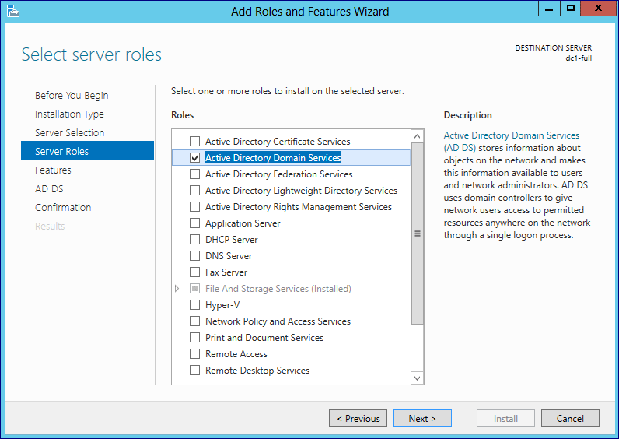

1. **AD DS Role Configuration**

This will be the the first domain in new forest

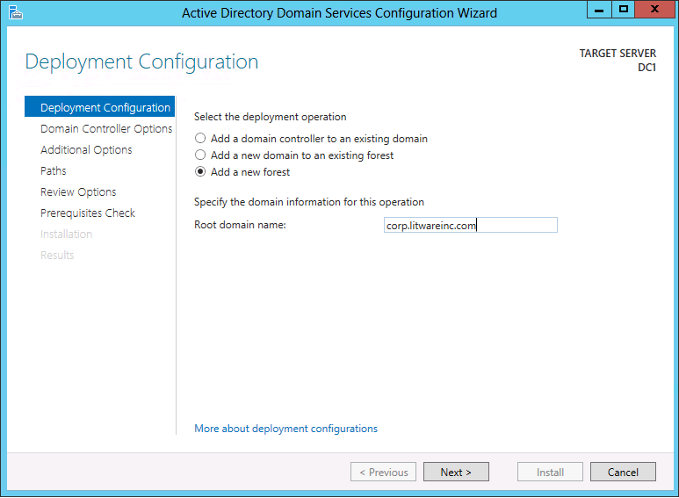

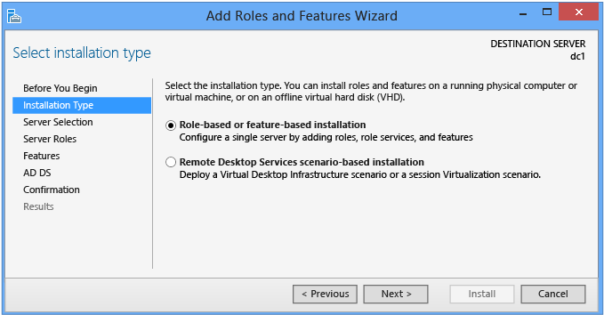

Always leave the default selection in place when installing AD DS: **Role-based or Feature-based Installation**.

1. **Server Roles and Features**

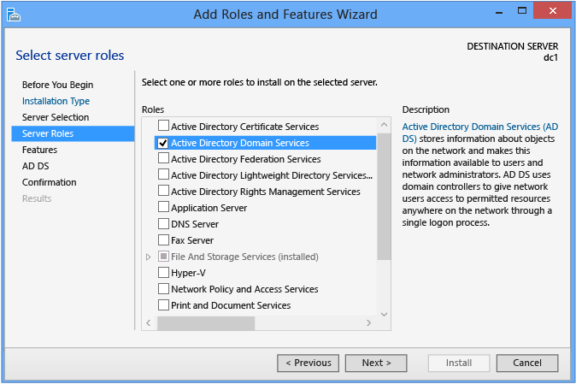

Select the **Active Directory Domain Services** role if you intend to promote a domain controller. All Active Directory administration features and required services install automatically, even if they are ostensibly part of another role or do not appear selected in the Server Manager interface.

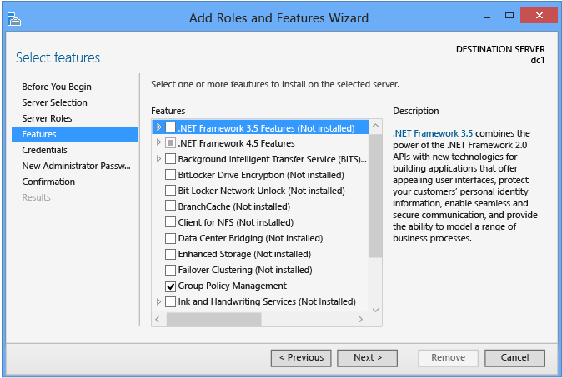

Additional **Features** can be added here as desired.

1. **Active Directory Domain Services**

The **Active Directory Domain Services** dialog provides limited information on requirements and best practices. It mainly acts as a confirmation that you chose the AD DS role " if this screen does not appear, you did not select AD DS.

1. **Confirmation**

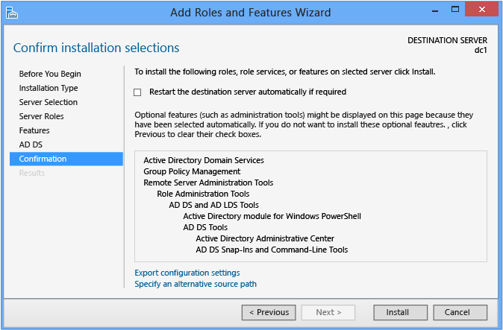

The **Confirmation** dialog is the final checkpoint before role installation starts. It offers an option to restart the computer as needed after role installation, but AD DS installation does not require a reboot.

By clicking **Install**, you confirm you are ready to begin role installation. You cannot cancel a role installation once it begins.

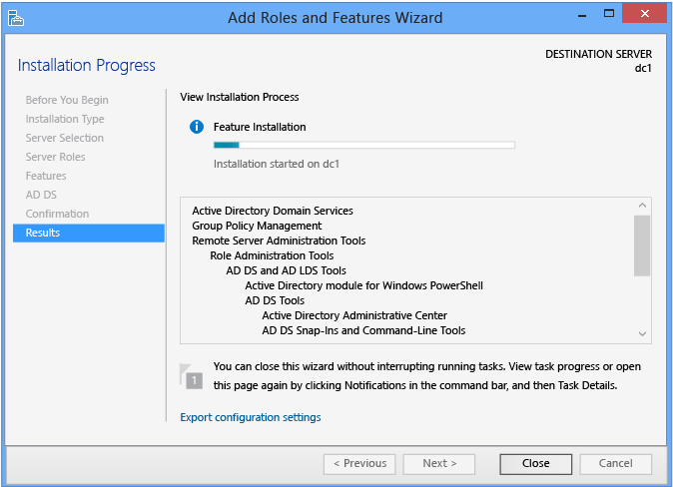

The **Results** dialog shows the current installation progress and current installation status. Role installation continues regardless of whether Server Manager is closed.

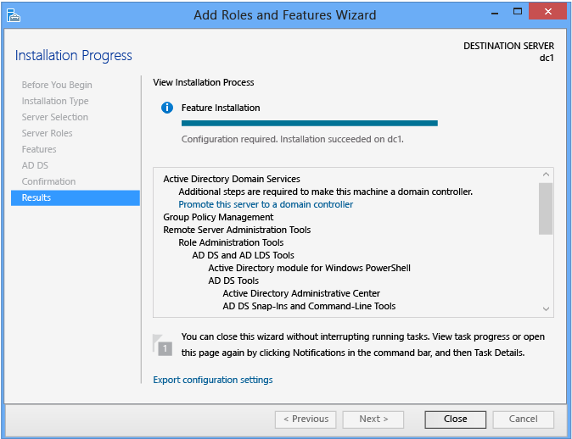

At the end of the AD DS role installation, you can continue with configuration by using the **Promote this server to a domain controller** link. This is required to make the server a domain controller, but is not necessary to run the configuration wizard immediately.

1. **Promote to Domain Controller**

Click on promote this server to a domain controller

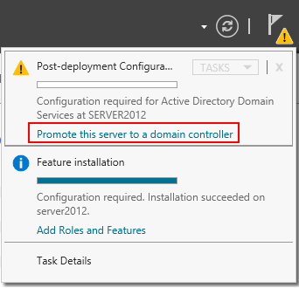

1. **Deployment Configuration**

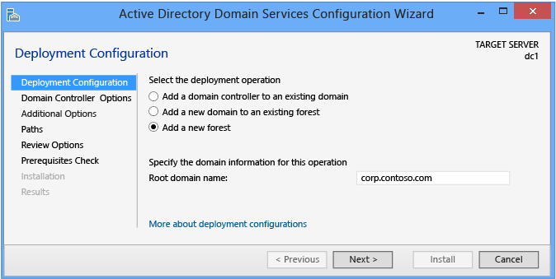

[Grab your reader’s attention with a great quote from the document or use this space to emphasize a key point. To place this text box anywhere on the page, just drag it.]

Server Manager begins every domain controller promotion with the **Deployment Configuration** page. The remaining options and required fields change on this page and subsequent pages, depending on which deployment operation you select.

To create a new Active Directory forest, click **Add a new forest**. You must provide a valid root domain name; the name cannot be single-labeled (for example, the name must be ***YourName.local*** and not just ***YourName***) and must use allowed DNS domain naming requirements.

1. **Domain Controller Options**

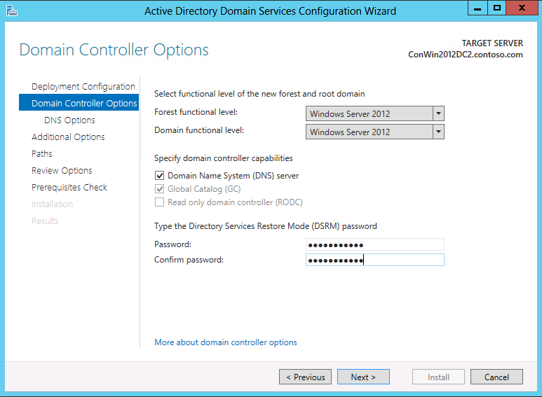

The **Domain Controller Options** enables you to configure the **forest functional level** and **domain functional level** for the new forest root domain. By default, these settings are Windows Server 2012 in a new forest root domain. flexibility of a more homogeneous or heterogeneous forest in terms of which operating systems are permitted to be run on domain controllers.

The only configurable domain controller capability is the DNS server option. Microsoft recommends that all domain controllers provide DNS services for high availability in distributed environments, which is why this option is selected by default when installing a domain controller in any mode or domain. The Global Catalog and read only domain controller options are unavailable when creating a new forest root domain; the first domain controller must be a GC, and cannot be a read only domain controller (RODC).

The specified **Directory Services Restore Mode Password** must adhere to the password policy applied to the server, which by default does not require a strong password; only a non-blank one. Always choose a strong, complex password or preferably, a passphrase.

1. **DNS Options and DNS Delegation Credentials**

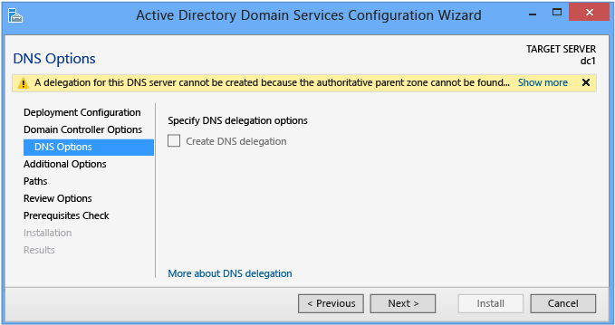

The **DNS Options** page enables you to configure DNS delegation and provide alternate DNS administrative credentials.

You cannot configure DNS options or delegation in the Active Directory Domain Services Configuration Wizard when installing a new Active Directory Forest Root Domain where you selected the **DNS server** on the **Domain Controller Options** page. The **Create DNS delegation** option is available when creating a new forest root DNS zone in an existing DNS server infrastructure. This option enables you to provide alternate DNS administrative credentials that have the rights to update DNS zone.

1. **Additional Options**

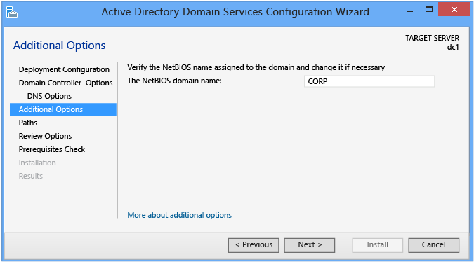

The **Additional Options** page shows the NetBIOS name of the domain and enables you to override it. By default, the NetBIOS domain name matches the left-most label of the fully qualified domain name provided on the **Deployment Configuration** page. For example, if you provided the fully qualified domain name of **dc1.YourName.local**, the default NetBIOS domain name is **YourName**.

If the name is 15 characters or less and does not conflict with another NetBIOS name, it is unaltered. If it does conflict with another NetBIOS name, a number is appended to the name. If the name is more than 15 characters, the wizard provides a unique, truncated suggestion. In either case, the wizard first validates the name is not already in use via a WINS lookup and NetBIOS broadcast.

1. **Paths**

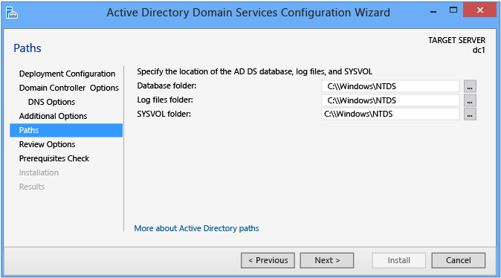

The **Paths** page enables you to override the default folder locations of the AD DS database, the database transaction logs, and the SYSVOL share. The default locations are always in subdirectories of %systemroot% (i.e. C:\Windows).

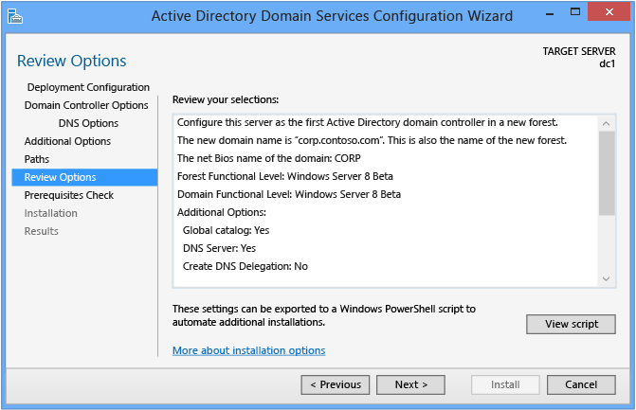

The **Review Options** page enables you to validate your settings and ensure they meet your requirements before you start the installation. This is not the last opportunity to stop the installation when using Server Manager. This is simply an option to confirm your settings before continuing the configuration

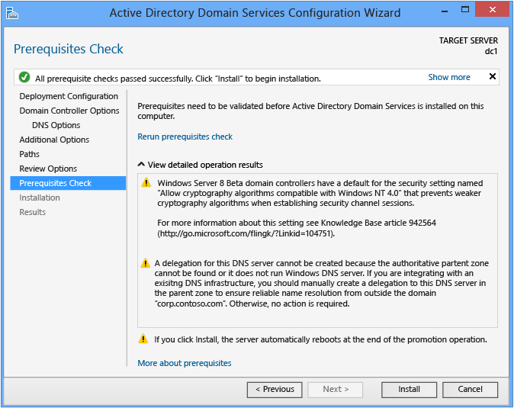

The **Prerequisites Check** is a new feature in AD DS domain configuration. This new phase validates that the server configuration is capable of supporting a new AD DS forest.

When installing a new forest root domain, the Server Manager Active Directory Domain Services Configuration Wizard invokes a series of modular tests. These tests alert you with suggested repair options. You can run the tests as many times as required. The domain controller process cannot continue until all prerequisite tests pass.

The **Prerequisites Check** also surfaces relevant information such as security changes that affect older operating systems.

1. **Installation**

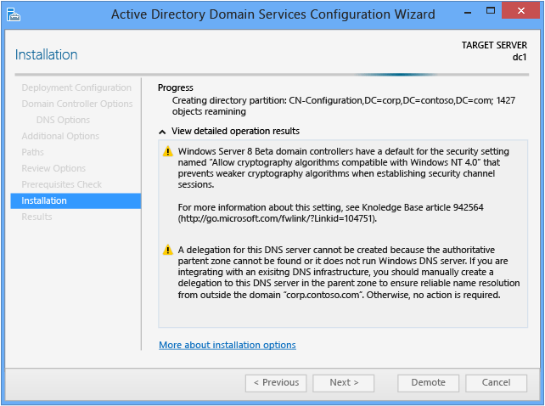

When the **Installation** page displays, the domain controller configuration begins and cannot be halted or canceled. Detailed operations display on this page and are written to logs:

* %systemroot%\debug\dcpromo.log
* %systemroot%\debug\dcpromoui.log

**NOTE**

You can run multiple role installation and AD DS configuration wizards from the same Server Manager console simultaneously.

**Results**

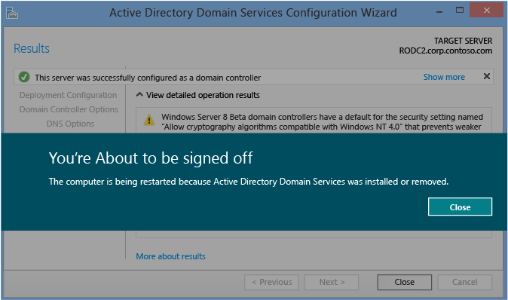

The **Results** page shows the success or failure of the promotion and any important administrative information. The domain controller will automatically reboot after 10 seconds.